
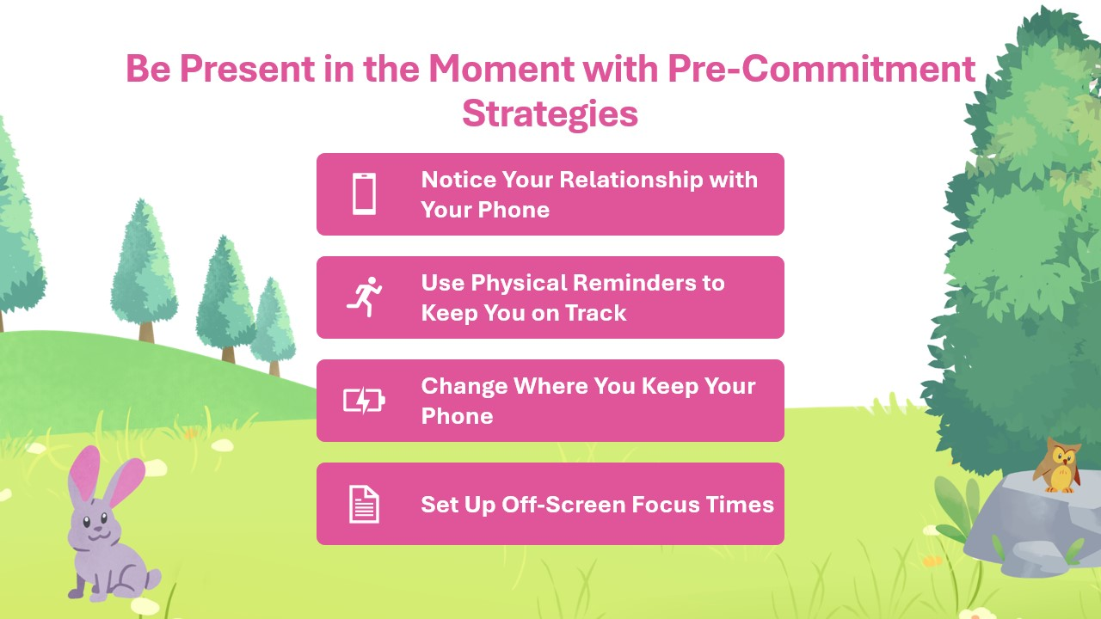
Add Your Own Strategies:
____________________________________________________________________________________________________________________________________________________________________________________________________________________________________________________________________________________________________________________________________________________________________________________________________________________________________________________________________________________________________________________________________________________________________________________________________________________________________________________________________________________________________________________________________________________________________________________________________________________________________________________________

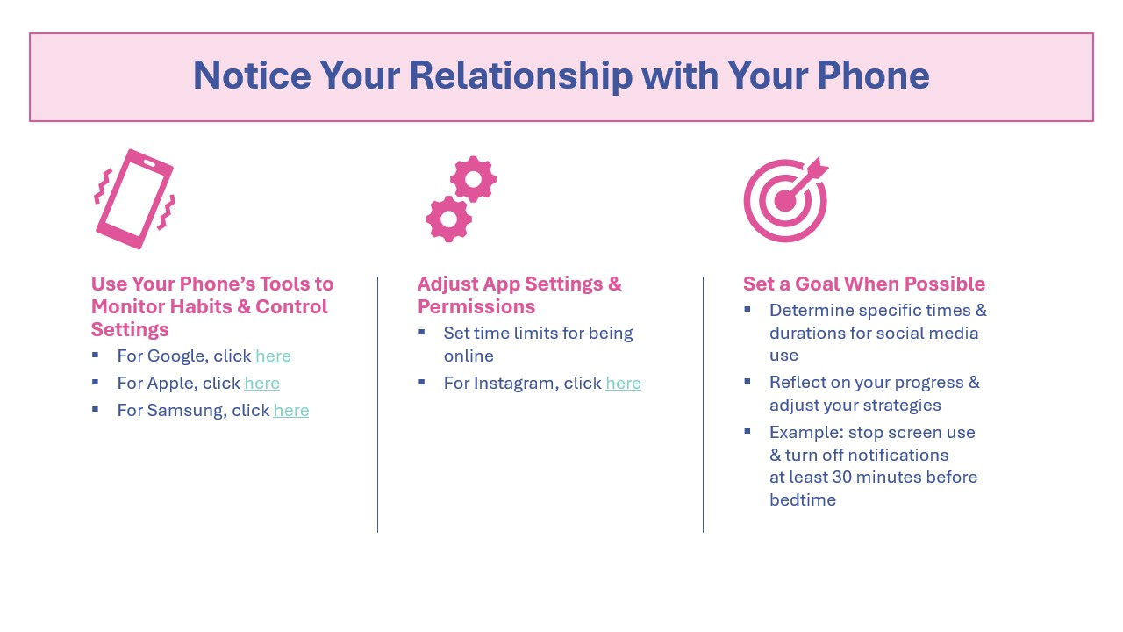
Add Your Own Strategies:
____________________________________________________________________________________________________________________________________________________________________________________________________________________________________________________________________________________________________________________________________________________________________________________________________________________________________________________________________________________________________________________________________________________________________________________________________________________________________________________________________________________________________________________________________________________________________________________________________________________________________________________________

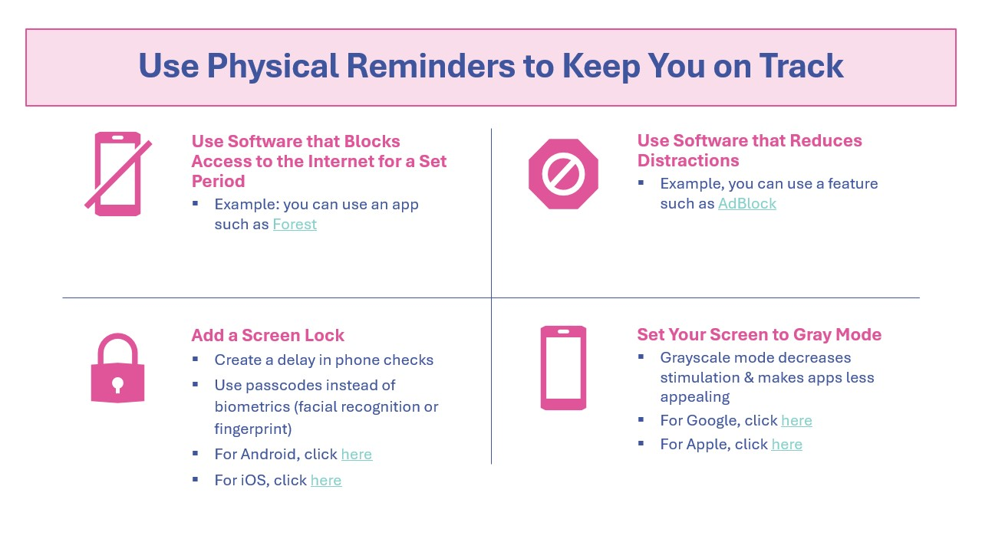
Add Your Own Strategies:
____________________________________________________________________________________________________________________________________________________________________________________________________________________________________________________________________________________________________________________________________________________________________________________________________________________________________________________________________________________________________________________________________________________________________________________________________________________________________________________________________________________________________________________________________________________________________________________________________________________________________________________________

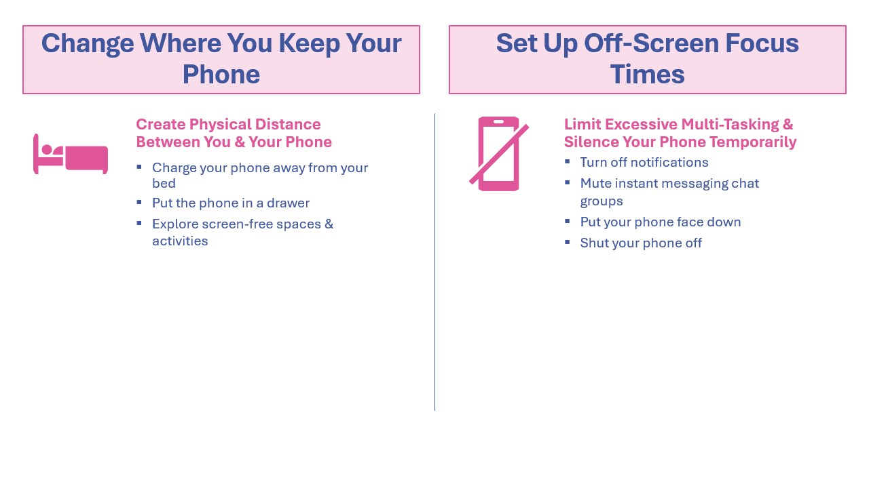
Add Your Own Strategies:
____________________________________________________________________________________________________________________________________________________________________________________________________________________________________________________________________________________________________________________________________________________________________________________________________________________________________________________________________________________________________________________________________________________________________________________________________________________________________________________________________________________________________________________________________________________________________________________________________________________________________________________________

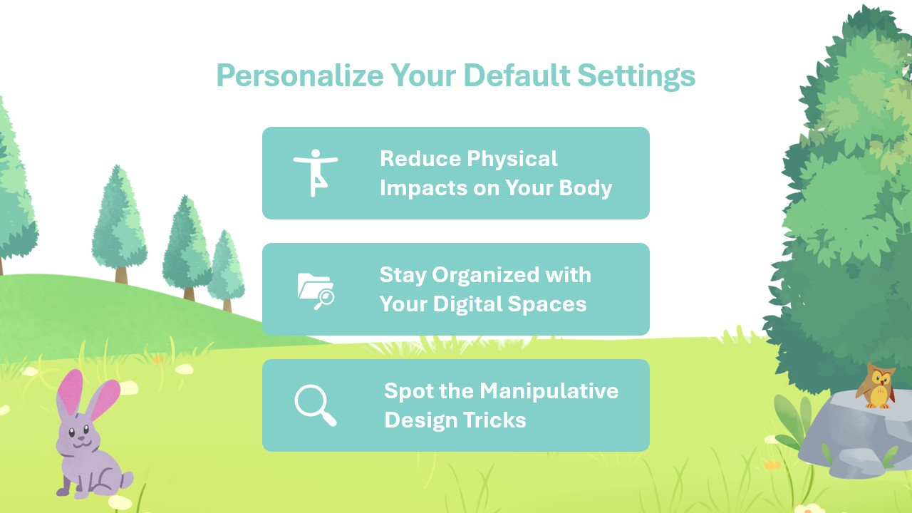
Add Your Own Strategies:
____________________________________________________________________________________________________________________________________________________________________________________________________________________________________________________________________________________________________________________________________________________________________________________________________________________________________________________________________________________________________________________________________________________________________________________________________________________________________________________________________________________________________________________________________________________________________________________________________________________________________________________________

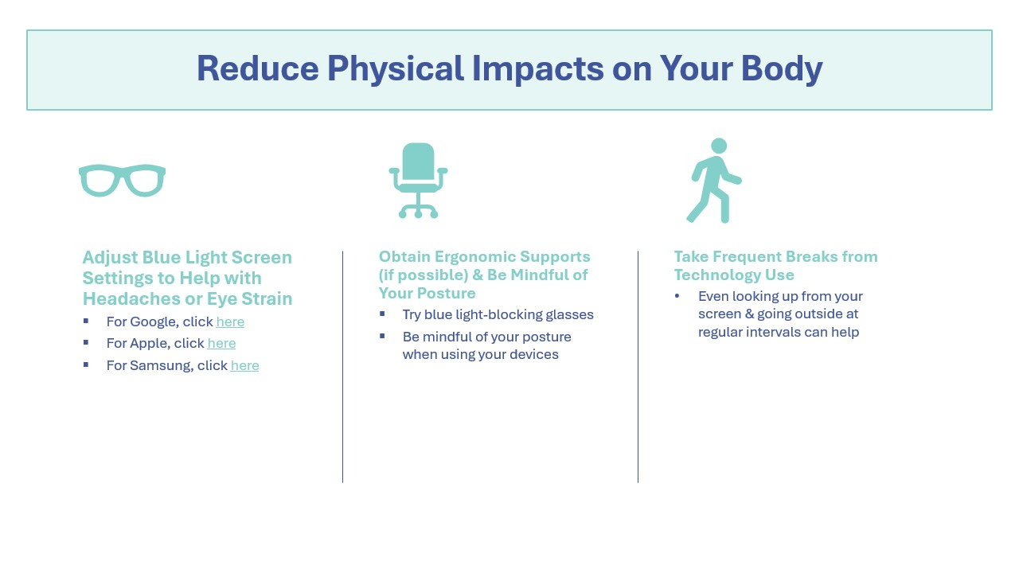
Add Your Own Strategies:
____________________________________________________________________________________________________________________________________________________________________________________________________________________________________________________________________________________________________________________________________________________________________________________________________________________________________________________________________________________________________________________________________________________________________________________________________________________________________________________________________________________________________________________________________________________________________________________________________________________________________________________________

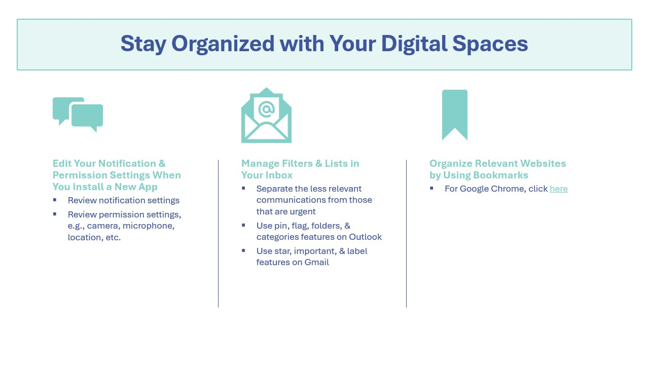
Add Your Own Strategies:
____________________________________________________________________________________________________________________________________________________________________________________________________________________________________________________________________________________________________________________________________________________________________________________________________________________________________________________________________________________________________________________________________________________________________________________________________________________________________________________________________________________________________________________________________________________________________________________________________________________________________________________________

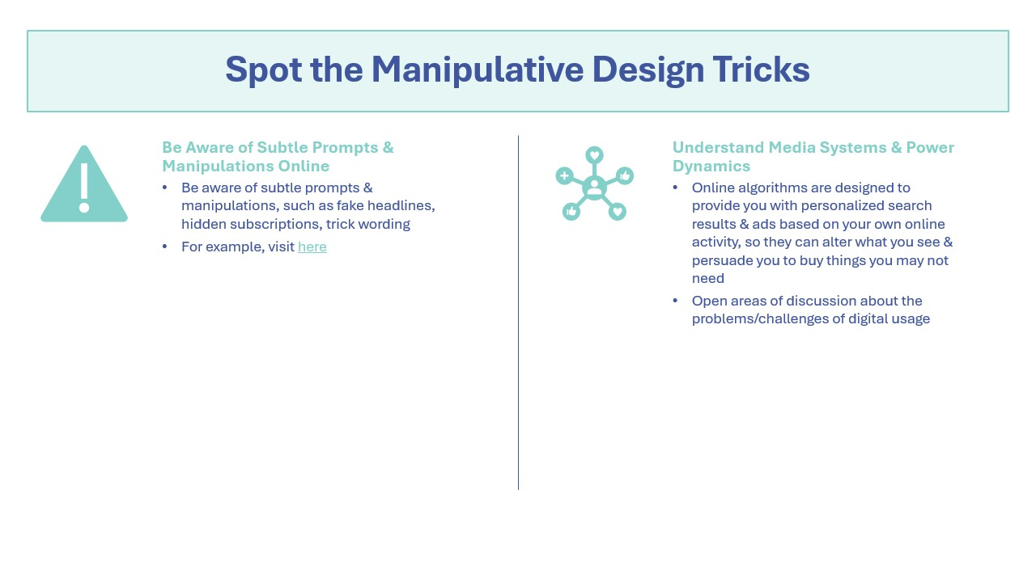
Add Your Own Strategies:
____________________________________________________________________________________________________________________________________________________________________________________________________________________________________________________________________________________________________________________________________________________________________________________________________________________________________________________________________________________________________________________________________________________________________________________________________________________________________________________________________________________________________________________________________________________________________________________________________________________________________________________________

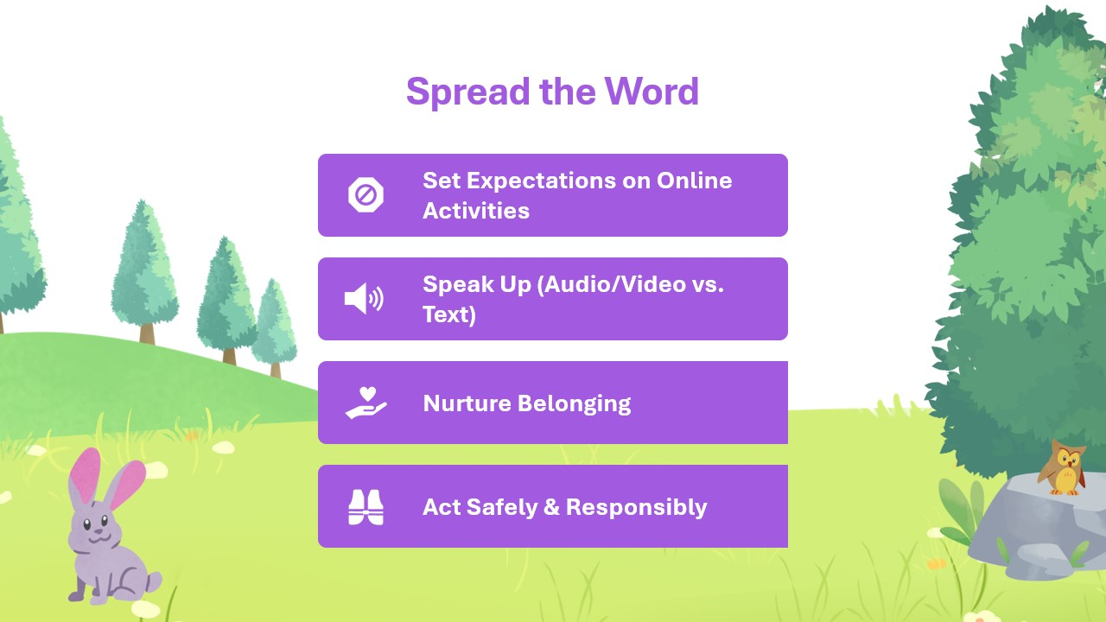
Add Your Own Strategies:
____________________________________________________________________________________________________________________________________________________________________________________________________________________________________________________________________________________________________________________________________________________________________________________________________________________________________________________________________________________________________________________________________________________________________________________________________________________________________________________________________________________________________________________________________________________________________________________________________________________________________________________________

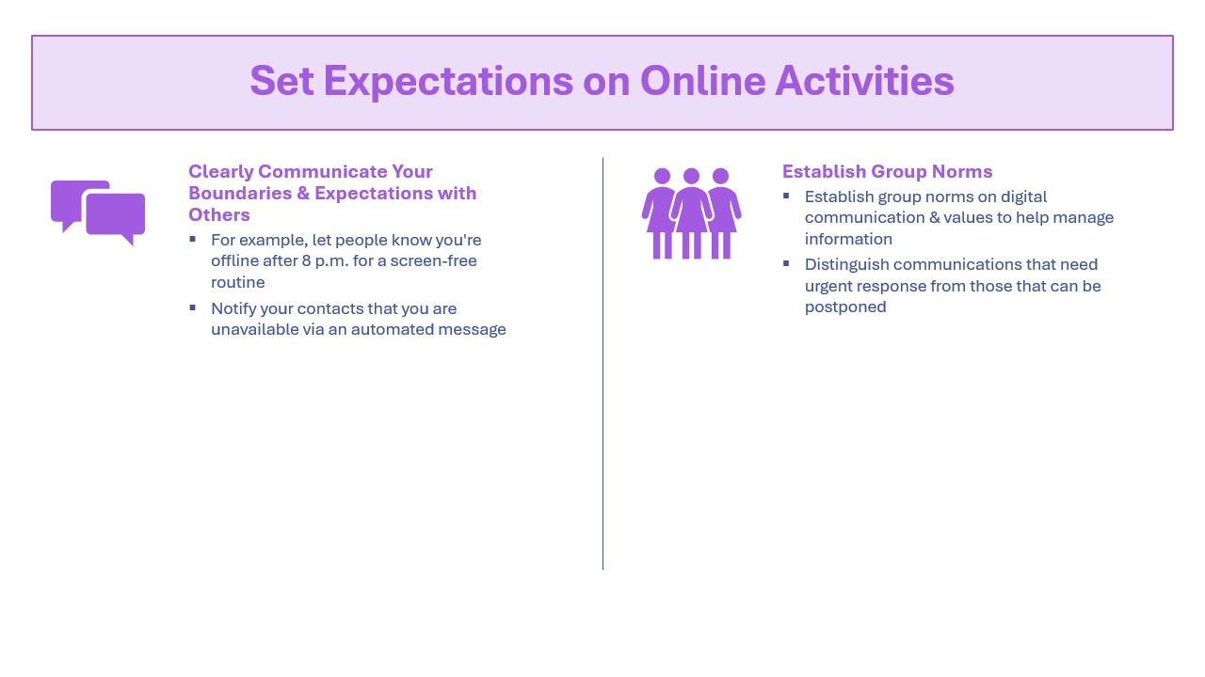
Add Your Own Strategies:
____________________________________________________________________________________________________________________________________________________________________________________________________________________________________________________________________________________________________________________________________________________________________________________________________________________________________________________________________________________________________________________________________________________________________________________________________________________________________________________________________________________________________________________________________________________________________________________________________________________________________________________________

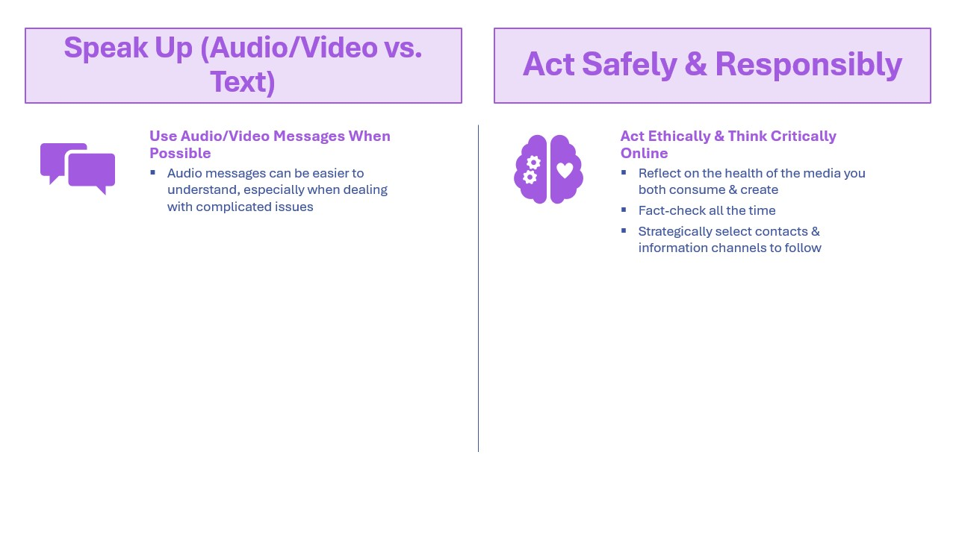
Add Your Own Strategies:
____________________________________________________________________________________________________________________________________________________________________________________________________________________________________________________________________________________________________________________________________________________________________________________________________________________________________________________________________________________________________________________________________________________________________________________________________________________________________________________________________________________________________________________________________________________________________________________________________________________________________________________________

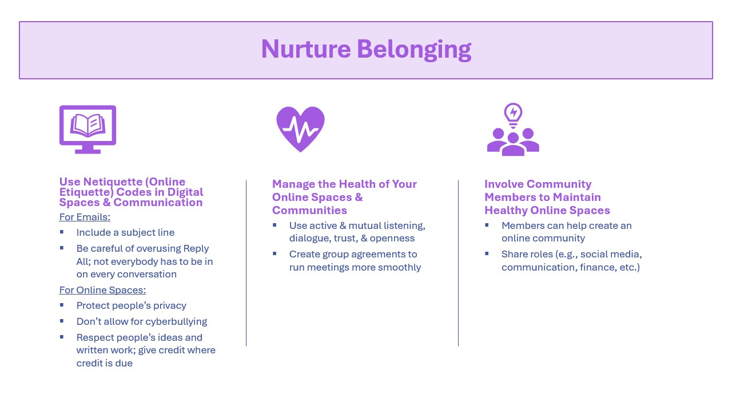
Add Your Own Strategies:
____________________________________________________________________________________________________________________________________________________________________________________________________________________________________________________________________________________________________________________________________________________________________________________________________________________________________________________________________________________________________________________________________________________________________________________________________________________________________________________________________________________________________________________________________________________________________________________________________________________________________________________________

